Seattle Solar Car Team Destructive Testing
Testing Version 2.1
SSCT
Alex Mill (Revised document writer)
Hagen Rankin (original document author)
Alain Semet (Mentor)
Kurt Gustafson (Design, Construction, and Testing Advisor)
July 2025

Contents
1 Background Information and Purpose 3
2 Destructive Testing 4
2.1 Initial Destructive Tests 4
2.1.1 Three Point Bend 4
2.1.2 Two-Sided Tension 4
2.2 Revised Tests 6
2.2.1 One-Sided Tension 6
2.3 Additional Testing 6
2.3.1 Edge Compression Test 7
2.3.2 Energy Absorption Test 8
3 Interpretation of Results 11
3.1 Roll Bar 11
3.2 Crush Zones 11
3.2.1 Measuring Frontal Crush Area 11
3.2.2 Energy Absorbed in a 45mph Collision 13
3.3 Safety Cell 14
3.3.1 Measuring Safety Cell Frontal Area 15
3.3.2 Safety Cell Strength 15
3.3.3 Collision Time (∆t) 15
3.3.4 Mean Force on Safety Cell - Factor of Safety 16
4 Collisions from Other Angles 17
4.1 Driver’s Right Impact 17
4.2 Driver’s Left Impact 17
4.3 Rear Impact 17
5 Conclusion 19
6 Acknowledgements 20
7 Appendix 21
Chapter 1

Background Information and Abstract
The Seattle Solar Car Team was born from the embers of another. After the Raisbeck Green Energy Team was disbanded, the members were still left with the hunger to continue the solar car spirit, and so we made our non-profit, reopened, and forged new fundraising pipelines, building a car from the ashes of our old team. We call this car EMBER. Through all of this, we faced new and recurring challenges that make the Solar Car Challenge, THE Solar Car Challenge.
With the team using carbon fiber boards to construct the frame and other structural elements, we are left with the challenge of proving the structural integrity of our car. Unlike the relatively simple modeling of steel, carbon fiber is less predictable and takes many resources to properly model. This leads to the reasons behind this paper, proving that the car is safe in a crash. We will use both destructive and non-destructive testing data to first establish the properties of the carbon fiber. After that, we will use the established properties to test the performance of the car in a head-on crash with a wall, a side collision, and a rollover.
For the head-on crash, we will assume an immovable object at a velocity of 50 mph, our new average speed. All side-on crashes will be at a speed of 30 mph, and the roll bar will be tested at 7.5 Gs of force. We will calculate this by hand using equations and data from our destructive testing. All things considered, the report will be mostly the same, apart from the justification, where we will completely redo the analysis and justification of the safety to reflect the fact that EMBER, although using the same materials, this car is a much different car than SOCKEYE.
By the end of this documentation, we will have fully detailed the structural properties of the materials used, how the properties result in the carbon's behavior in a crash, the safety of the driver and battery in a crash, and any other relevant information regarding the safety of EMBER.
Chapter 2

Destructive Testing
We’ve designed the frame of EMBER to have the strength of a well-made steel frame, and we acknowledge that the rules state we need to prove this. As defined by rule 5.2.4 of the 2025 Solar Car Challenge Rules, we needed to have an organization specializing in destructive testing test samples of our composite frame to ensure our roll bar, crush zones, and safety cell have comparable strength to a metal structure. In our initial tests, both a three-point bend and a two-sided tension test. The two-sided tension test in particular showed forces so high we questioned our methodology (Fig. 9.3). After discussing with Mr. Gustafson, we decided to run a one-sided tension test to better simulate actual forces on the car. Sure enough, the strength was approximately half that of the two-sided tension test, as we expected (Fig. 9.4). Finally, with the assistance of Mr. Gustafson, we ran our energy absorption and edge compression tests to measure the abilities of the safety cell and crush zone.

2.1 Initial Destructive Tests
An alumni Raisbeck Aviation High School student and RAHS green energy team, Hai Lin Truman, had worked a summer internship at Boeing’s destructive testing facility. So, we worked with his contact to have samples of our Gilfloor 4709 tested (Fig. 9.1). Specifically, Boeing ran a three-point bend and two-sided tension test on our material samples.

2.1.1 Three Point Bend
For the three-point bend test, we manufactured five 24in by 3in aramid honeycomb core carbon fiber sandwich panel samples (Fig. 4.1) out of Gillfloor 4709 (Fig. 9.1) for the standardized 3-point bend. This test was initially used to simulate a side-on impact to either our crush zone or safety cell; however, we later realized that most of the energy absorption would come from the frame members positioned perpendicular to the collision. For this reason, we decided to run an energy absorption test, which we used in the defense of our crush zones. (Data: Fig 9.2).
Sample | 1 | 2 | 3 | 4 | 5 | Mean
Peak Load (pound-force) | 203.5 | 178.9 | 195.5 | 180.5 | 199.7 | 191.6
Table 4.1: 3 Point Bend Data Summary (See Fig. 9.2)

2.1.2 Two-Sided Tension
For our first tensile strength test, the two-sided tension test (Data: Fig 9.3), we manufactured five 3in x 6in carbon fiber samples (Fig 4.2) out of Gillfloor 4709 (Fig 9.1). Then, we bonded two sets of aluminum brackets, one as a solid mount with three bolts, and one as our testing bond with one bolt. In the data, ignore TNS-1B, as it is a tension test without testing bond brackets. To attach the brackets, we used the same method as for the rest of the car (suspension, seat belts, roll bar, etc.), which is to bond the bracket to the composite with 3M Scotch-Weld Epoxy Adhesive EC-2615 B/A. Then we secure the brackets in place with a 0.25-inch bolt and an aluminum spacer between the brackets. The surface area of the plate in this test was 3.541 inch² per side per sample.
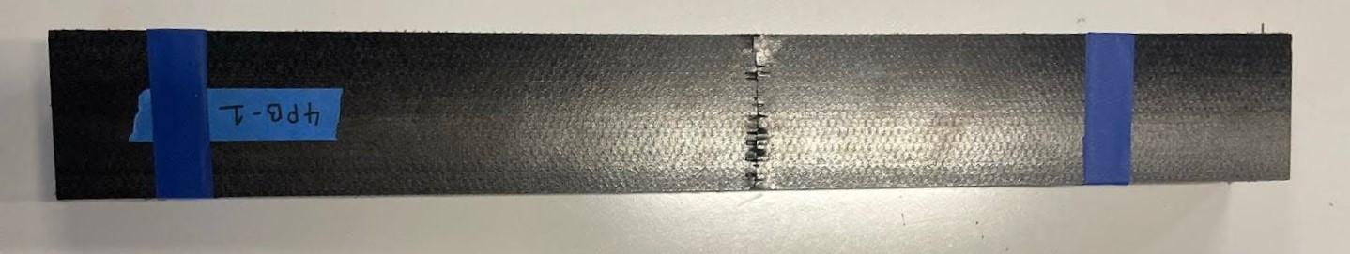
Figure 4.1: 3pt Bend Test Sample

Sample | 1 | 2 | 3 | 4 | 1B (Ignore)
Peak Load (pound-force) | 9007.5 | 7561.5 | 7909.6 | 7996.8 | 591.3
Table 4.2: Two-Sided Tension Data Summary (See Fig. 9.3)
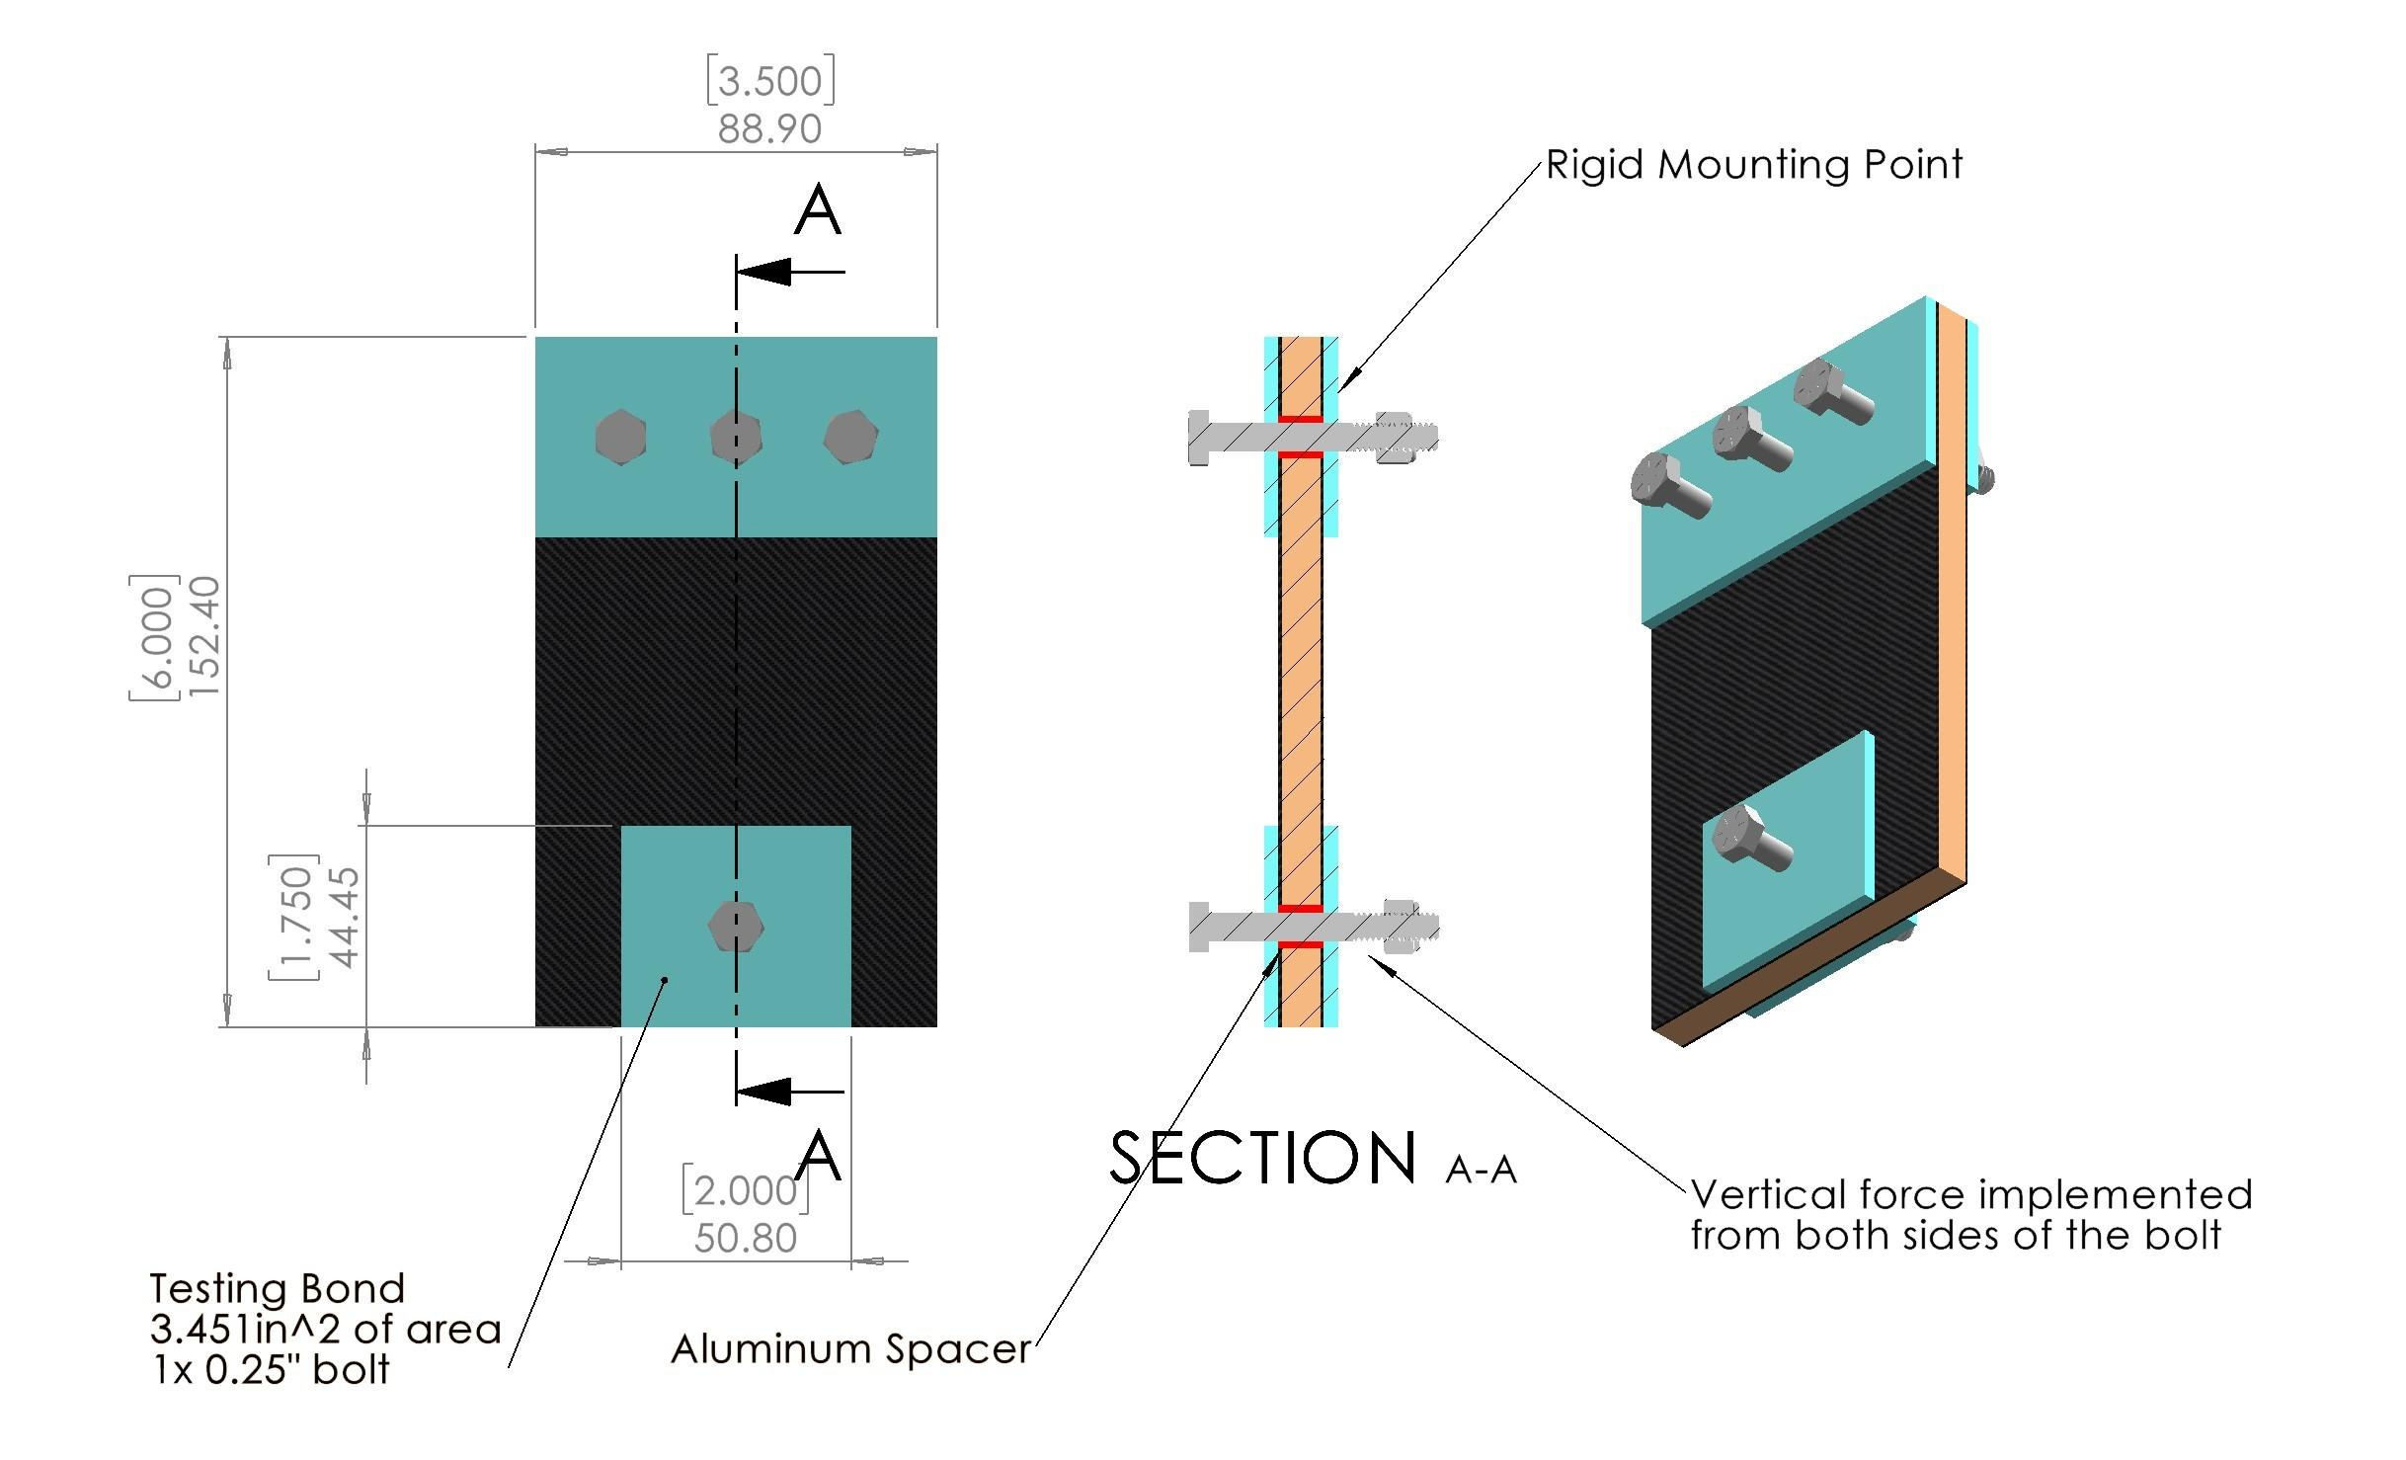
Figure 4.2: Two-Sided Tension Drawing

2.2 Revised Tests
After discussing with Mr. Gustafson, we noticed that while our test sample simulated a load pulling evenly across both sides of the composite panel, the actual load by our suspension, roll bar, seat belt mounts and more would only have forces going to one side of the bracket, applying a moment to the joint. So, we decided to run a one-sided tensile strength test, where the same sample is used but is only loaded from one side of the bolt. Happily, Boeing’s destructive testing facility agreed to run this additional test.

2.2.1 One-Sided Tension
The sample for the one-sided tension test was the same as the two-sided tension test. However, instead of the load being applied evenly from both sides of the 0.25-inch bolt, the load was applied entirely to one side of the bolt (Fig. 4.3). As expected, this resulted in approximately half the tensile strength of the two-sided test. (Data: Fig 9.4).
Sample | 1 | 2 | 3 | 4 | 5
Peak Load (pound-force) | 2878.622 | 4129.079 | 3233.783 | 3761.897 | 3247.839
Table 4.3: 1 Sided Tension Data Summary (See Fig. 9.3)
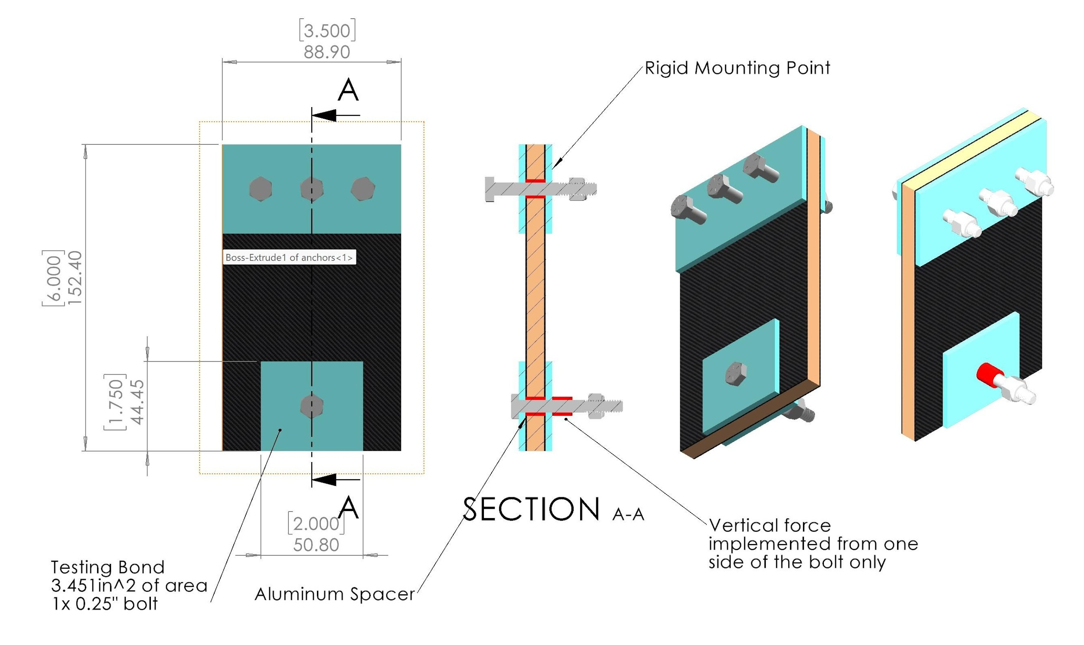
Figure 4.3: One-Sided Tension Drawing

2.3 Additional Testing
While the one-sided tension test provided useful data for our mounting bracket parts, such as seat belts, the roll bar, and more, we needed more test data to measure the efficiency of our crush zones and the strength of the safety cell. For these tests, since our contact at Boeing had graduated, we instead worked closely with Mr. Gustafson to conduct our tests. We conducted a surface pressure resistance test, which tells us the strength of our composite paneling and, therefore, of our safety cell. We also conducted an energy absorption test, which integrates force concerning displacement of material to find the amount of energy absorbed by the carbon fiber in a collision.

2.3.1 Edge Compression Test
One test we ran was an edge compression test. Since our scale measured a maximum force of 180kg, it was difficult to find the right size crush sample that would crush the composite without maxing out the scale. After some experimentation, we decided to use a 0.25-inch wide aluminum crush device, which, multiplied by two 0.01-inch-wide carbon fiber walls, gives us a cross-sectional area of 0.005 in² (Visual: Fig 4.4). We used a press to push the device into the composite, measuring the force just before permanent deformation (Fig. 4.5). We measured three different samples, and in our analysis will use the worst performing result, which is approximately 37400 PSI. See (Table 4.4).
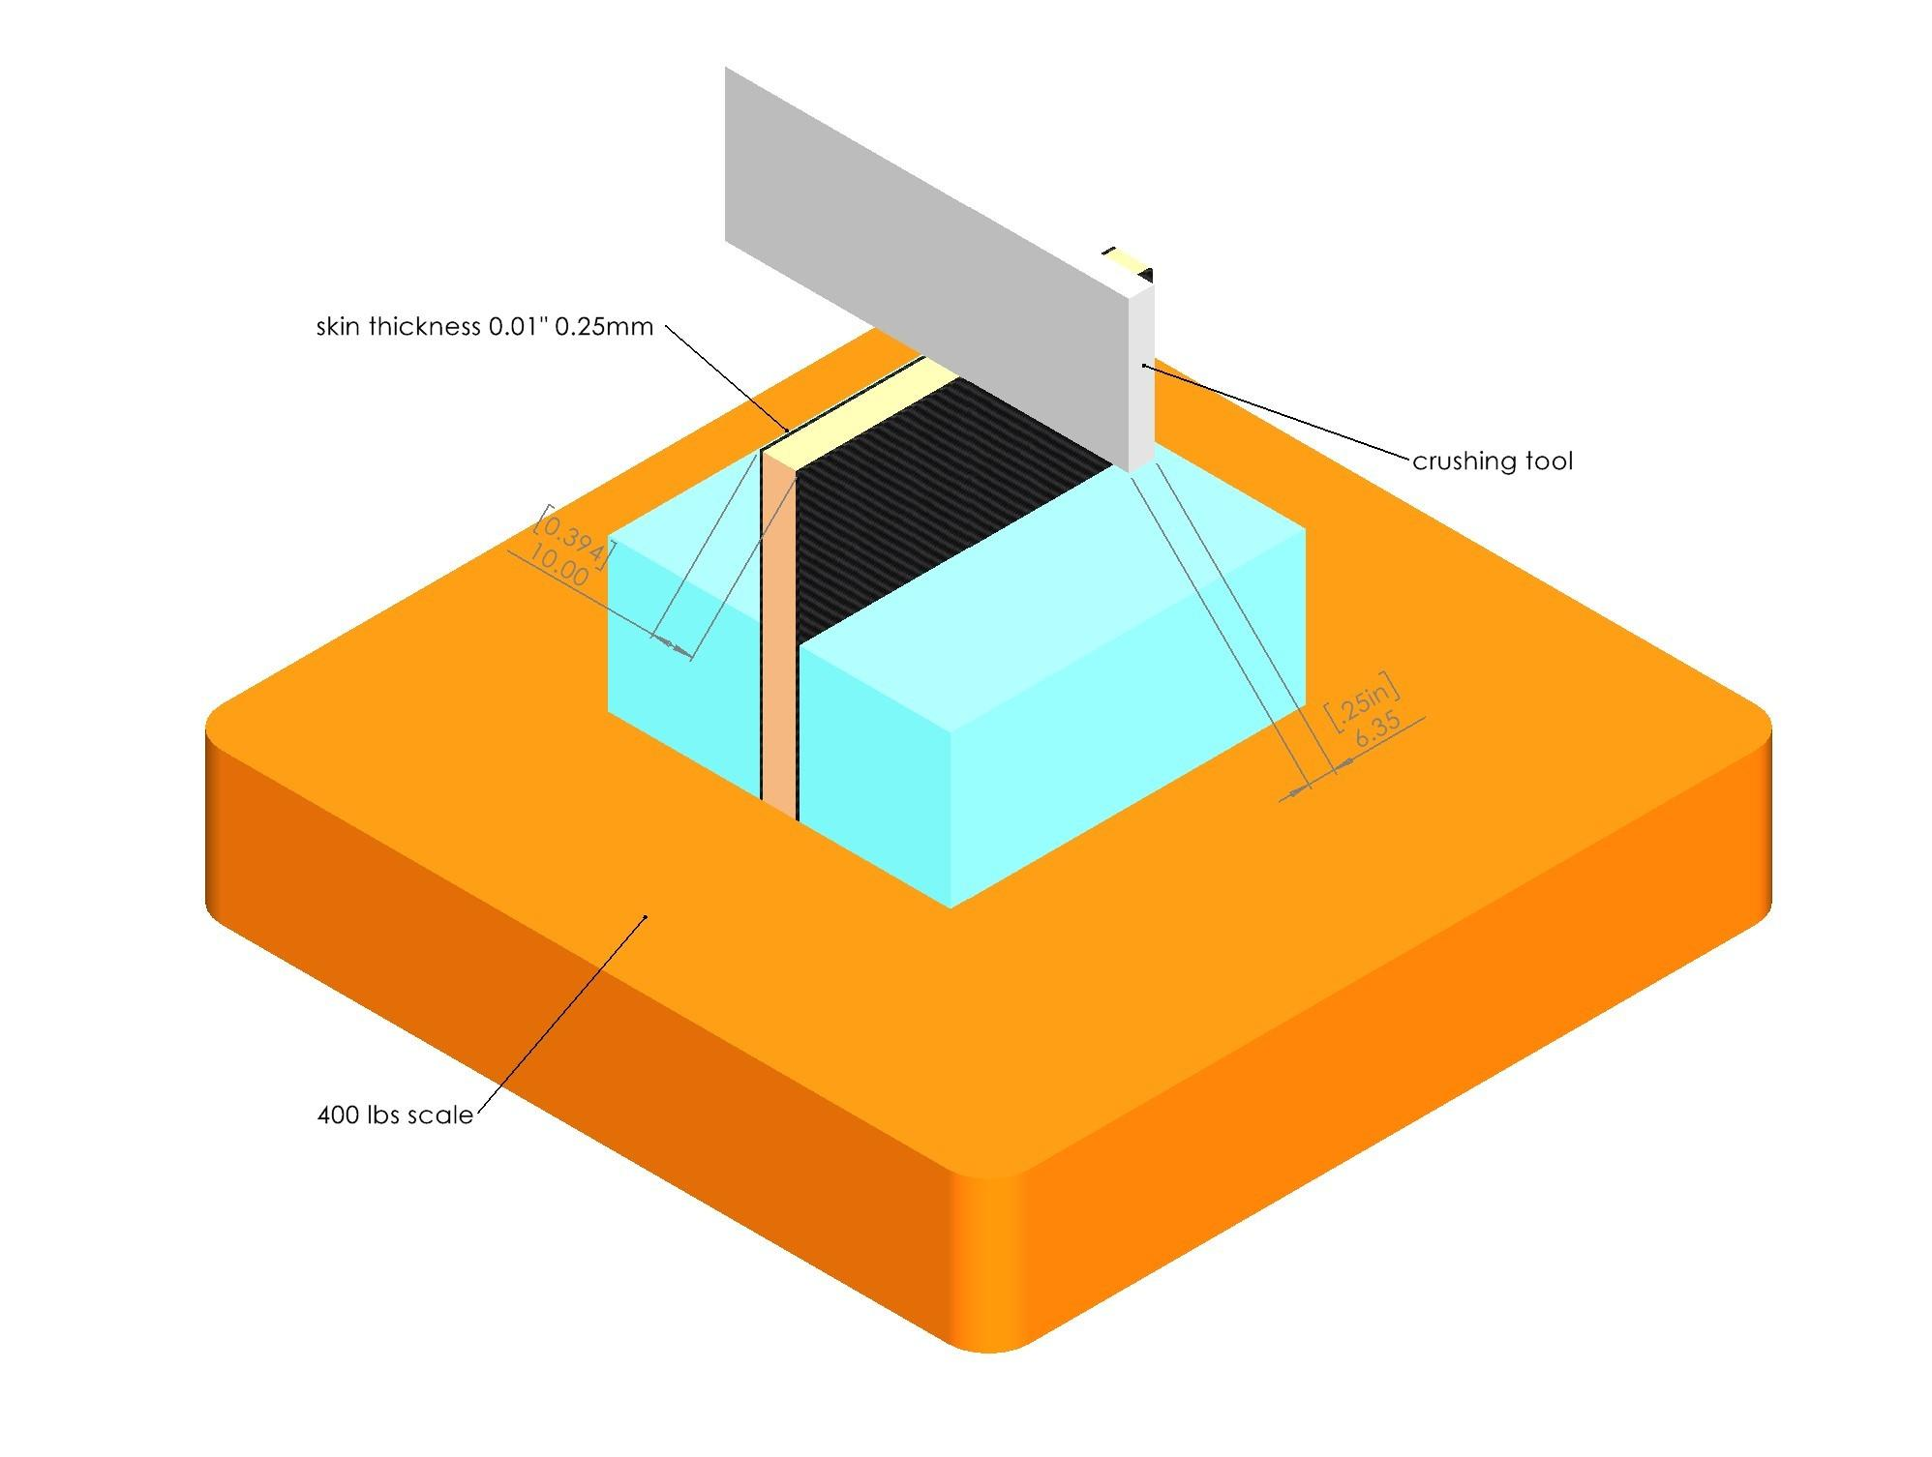
Figure 4.4: Edge Compression Test Drawing
Sample | Force(pound-force) | Area Broken (in²) | Strength (PSI)
1 | 262 | 0.005 | 52400
2 | 187 | 0.005 | 37400
3 | 240 | 0.005 | 48000
Table 4.4: Gillfloor 4709 Edge Compression Test Data
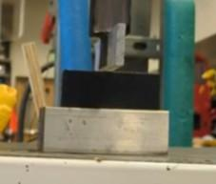
Figure 4.5: Surface Pressure Resistance Test Image

2.3.2 Energy Absorption Test
Our final test was our Energy Absorption Test. For this test, we crushed a sample of composite vertically (Fig. 4.7), measuring both the instantaneous force and displacement at different distances. This gives us work, because work is the integral of force with respect to displacement. Work is the total use of energy to crush the composite. In this context, work will be interpreted as the energy that can be absorbed by the composite panels.
W = Fdx
To conduct the test, we measured three samples. Each sample was a vertically oriented piece of Gillfloor 4709, which we crushed using a 15.875mm wide crush tool. We measured the force with a scale, measuring from when the tool first started to break the composite until the tool reached the fiberglass corners to ensure we were only measuring the energy absorption characteristics of the carbon fiber itself. In reality, the energy absorption should be greater than measured since we are not accounting for the additional fiberglass corners, stiffness from the aerodynamic shell, and suspension.
To calculate as accurately an integral as possible, we measured the force at any stable point and also recorded the displacement. We measured the displacement using a virtual ruler and accounted for deflection in the scale by finding the ratio of deflection to force and accounting for this in our data. This was about 7mm less than displayed on the virtual ruler per 180 kg of force on the scale. Then, we calculated the integral of the force concerning the displacement using a trapezoidal Riemann sum. Data for this test can be found in tables 4.5, 4.6, and 4.7.
After integrating, we converted to the standard unit for work (joules) and calculated the total crushed composite surface area. Then, we divided the energy absorbed by the surface area to get the energy absorbed in Joules per square inch of composite surface area (See Table 4.8) For future calculations, we will assume the worst for the sake of safety and use our lowest value for energy absorption which occurred with sample three and had a value of 42.9 J/in².
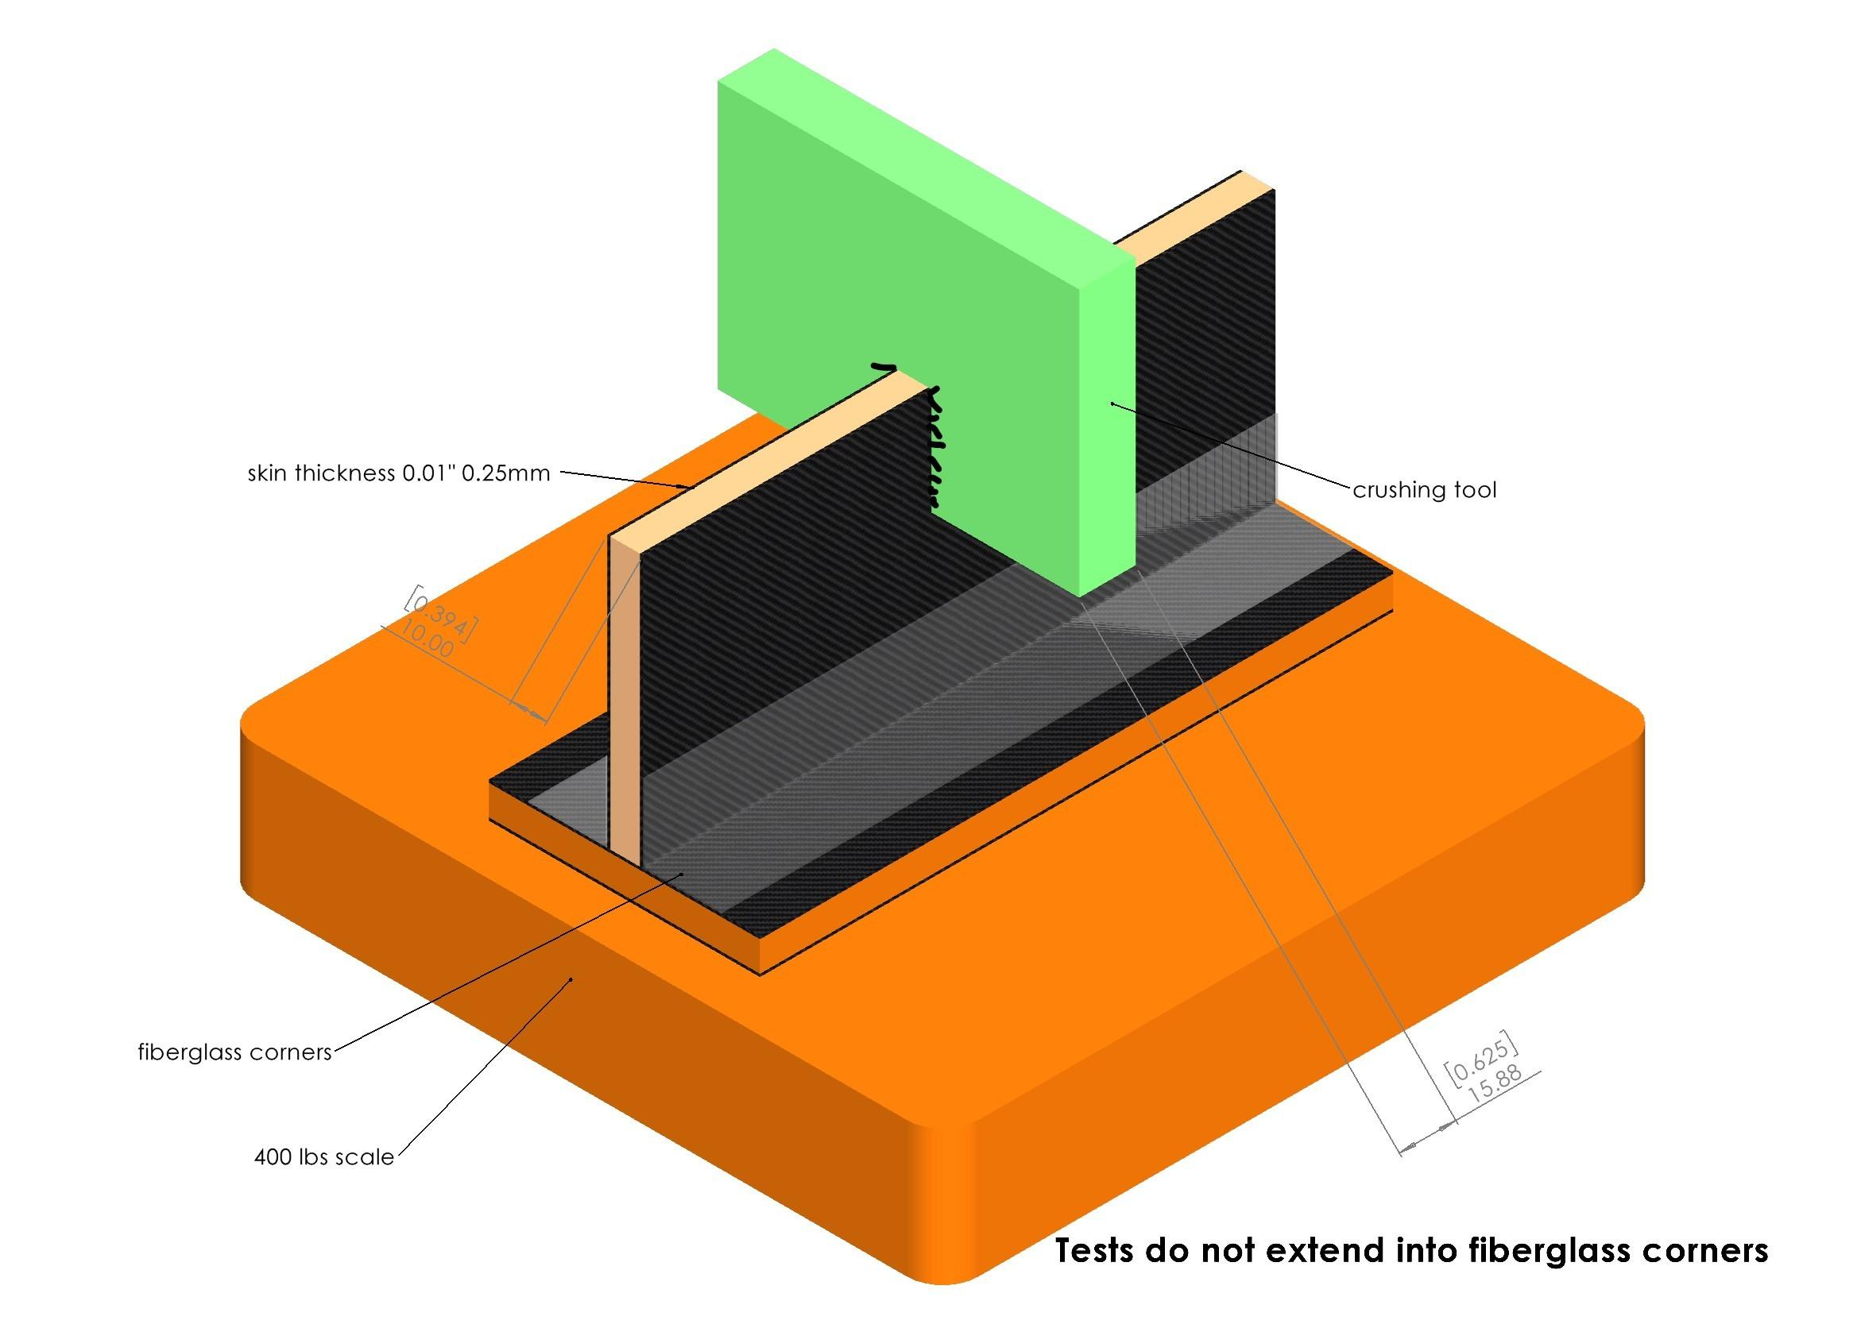
Figure 4.6: Energy Absorption Test Drawing
Force (kgf) | Displacement (mm)
180 | 2.0
172 | 6.3
126 | 12.1
96 | 19.3
97 | 24.2
124 | 30.2
125 | 38.1
135 | 38.8
130 | 44.9
150 | 51.2
128 | 58.0
Table 4.5: Energy Absorption Test Sample One Data
Force (kg) | Displacement (mm)
171 | 0.4
123 | 6.2
137 | 7.7
118 | 19.4
110 | 24.7
165 | 39.6
180 | 49.0
Table 4.6: Energy Absorption Test Sample Two Data
Force (kg) | Displacement (mm)
143 | 2.4
112 | 12.6
69 | 18.3
137 | 36.7
109 | 47.8
150 | 51.2
125 | 38.1
135 | 38.8
130 | 44.9
150 | 51.2
128 | 58.0
Table 4.7: Energy Absorption Test Sample Three Data
Test Sample | Crushed Area (in²) | Energy Dissipation (J) | Absorption Per Area(J/in²)
1 | 1.42 | 71.31 | 49.9
2 | 1.21 | 6 6.92 | 55.5
3 | 1.26 | 54.05 | 42.9
Table 4.8: Energy Absorption Test Data Summary
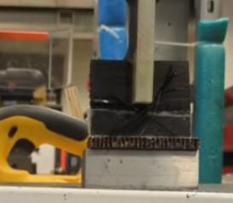
Figure 4.7: Energy Absorption Test Image

Chapter 3

Interpretation of Results

3.1 Roll Bar
For the mount of the main roll bar, we use a 2” OD 0.065” thick carbon steel tube bent continuously, which meets the Solar Car Challenge Rules. However, the tube needs to be mounted to our carbon fiber safety cell, and then bonded in a way that makes it an integral part of the safety cell structure. To achieve this, we welded the roll bar to epoxy and bolt mounting brackets as specified in the tension tests. The mounting bracket consists of two metal plates that are bonded to the frame using 8 x ⅜ in grade 8 bolts and Scotch-Weld™ 2216 epoxy. Our one-sided tensile strength test was used to measure the strength of these bonds in the form of surface area per bolt. The load was distributed to the bolt from one side, much like the actual application of the roll bar. Even with ¼ in bolts (less than the actual roll bar), the minimum point of failure was 2878 pound-force per bolt (Figure 9.4).
A safe maximum (unexpected) load would be a 10 G collision imposed vertically on the roll bar. With our predicted car weight and driver weight totalling to 450 lbs, this would result in a 4500 pound-force load. When distributed throughout the 8 bolts, that comes out to 562.5 pound-force per bolt. Comparing this to our tested strength per bolt of 2878 pound-force (Figure 9.4), we have a trustworthy factor of safety of 5.1 with a 10 G collision, without consideration of the stronger bolts and extra surface area.
It should also be noted that there is extra stiffness not accounted for in this test due to the structures designed to divert the solar array from the driver in the event of a collision (Fig. 5.1). While we do not need this to make the roll bar strong, it provides noteworthy additional stiffness and rigidity in each plane.

3.2 Crush Zones
To measure the capabilities of our crush zone, we calculated how much energy our crush zones are able to absorb. We did this by conducting our energy absorption test, and then calculated both how much energy can be absorbed by our crush zones, combining with how much energy would be involved in a head-on collision at 50mph. Afterwards, we can compare these two numbers to analyze the effectiveness of our crush zone.

3.2.1 Measuring Frontal Crush Area
Measuring the area that crushes in a head-on collision, we used Solidworks to measure all areas we expect to crush that are perpendicular to the front of the car. This resulted in a total expected crush area (in a head-on collision) of 949.28 in².
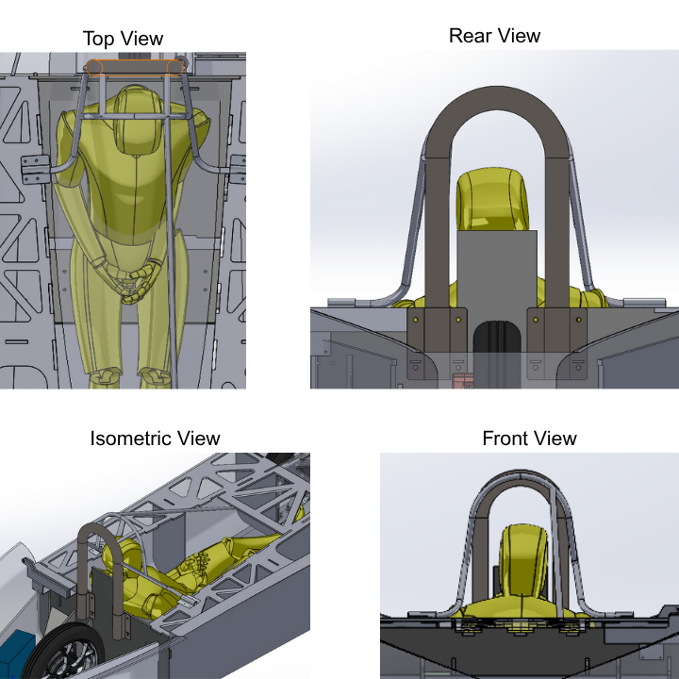
Figure 5.1: Roll Bar Design and Mount

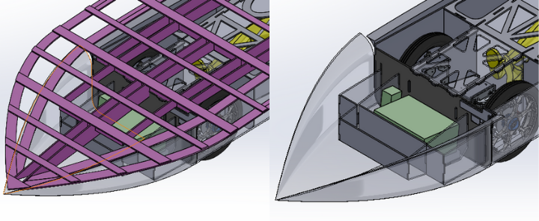
Figure 5.2: Frontal Crush area

3.2.2 Energy Absorbed in a 50mph Collision
To calculate the amount of energy that needs to be absorbed in a head-on collision at 50 mph, we used the kinetic energy equation (below) where K_{E} is in joules, m is in kilograms, and v is in meters/second.
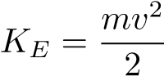
Plugging in unit converted values for 50 mph and a 450 lb car and driver, we get 50,990 joules that will either need to be absorbed by the crush zone or brought to a stop by the crush zone.
Our worst-performing energy absorption test indicates an energy absorption of 42.93J/in². With our total crush area of 1,378.989 in², the total possible energy absorption before the safety cell is impacted is 59,200 J

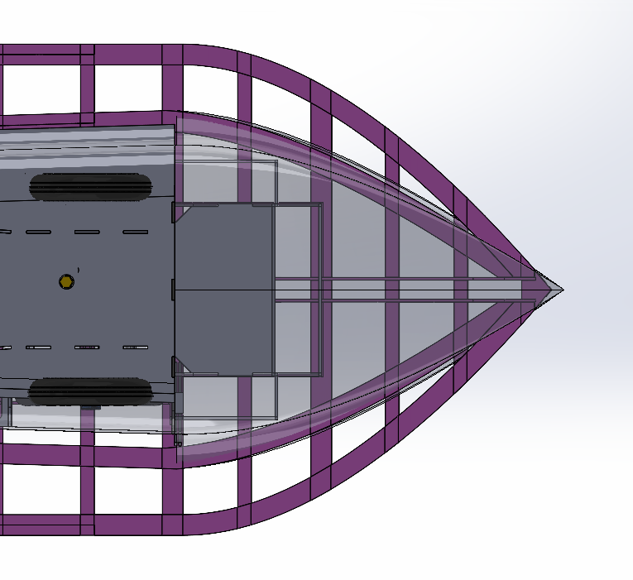Figure 5.3: Frontal Crush Area Cont.
This means that the crush zone is expected to be able to absorb up to 116.1% of the energy in a head-on collision at 50mph, so the crush zone would successfully bring the car to a stop, leaving the safety cell intact. This is also not including the additional energy absorption from our foam fairings and additional carbon added for fairing support.

3.3 Safety Cell
To measure the effectiveness of the safety cell, we will again be analysing a scenario of a head-on collision at our cruising speed of 50mph. For the safety cell analysis, we will calculate the maximum amount of force that the cell can withstand. Since we expect the safety cell to absorb all the energy of the collision, we will then calculate the amount of time the collision occurs over and the force on the safety cell throughout the collision. The safety cell strength divided by the collision force will give us a factor of safety for the safety cell during a 50mph collision.
To measure the force on the safety cell, we will use the impact force equation.
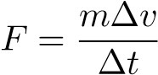

3.3.1 Measuring Safety Cell Frontal Area.
For the area that we expect to stay intact in a collision, we are measuring the frontal area of the outer layers only of our Gillfloor 4709 composite paneling. To measure this, we looked at a split view of our car in Solidworks where the crush zone ends and the safety cell begins, measuring the total distance of all the side lengths (Fig. 5.4) and multiplying by the thickness of the composite of 0.01 inches. This resulted in a measured frontal area of 0.994 in².
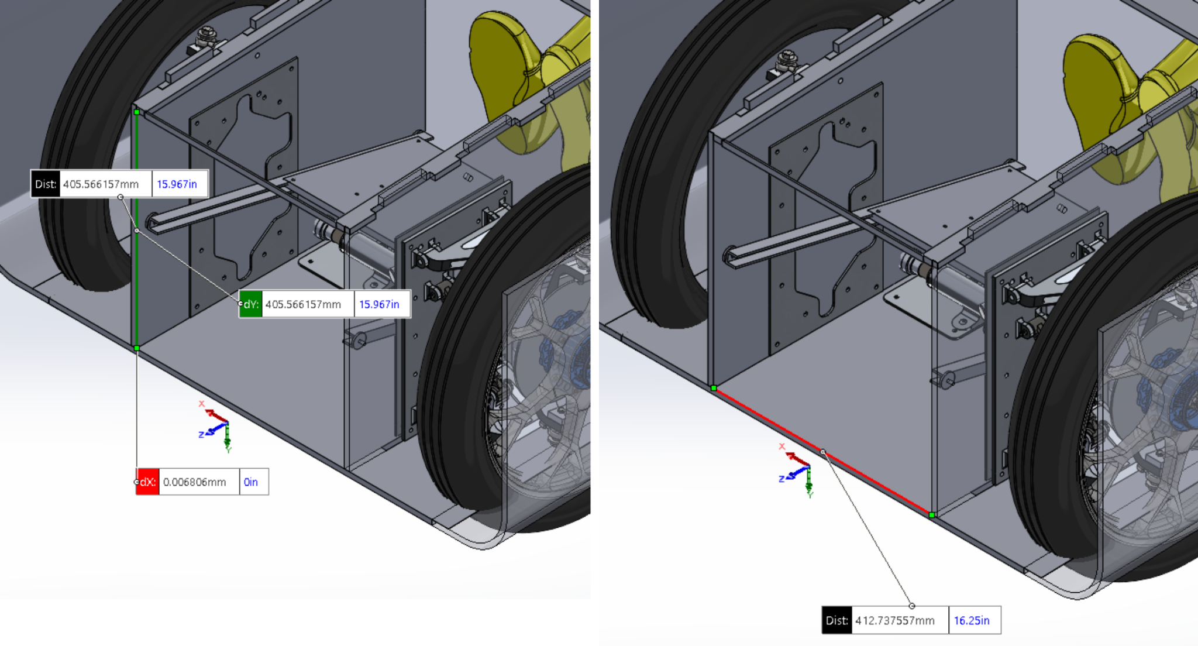
Figure 5.4: Frontal safety cell measurements

3.3.2 Safety Cell Strength
Using the data from our composite skin edge compression test, we multiplied our frontal area measurement by the strength of the composite skin (See Edge Compression Test) to get 165,365N. This is the amount of force the front of our safety cell can handle before we would expect it to permanently deform.

3.3.3 Collision Time (∆t)
One key aspect of the impact force equation is the collision time. This is the time it takes for EMBER to go from its cruising speed of 50mph or 22.352 m/s to a complete stop.
To simplify this documentation, we will only be measuring the second section of our front crush zones. While the aerodynamic shell and forward-facing bulkhead does absorb energy, it is easier to assume that the deceleration will be linear over the distance we measured (Fig. 5.5). In actuality, the deceleration will be much more gradual, and the impact force on the safety cell will be lower. Our measurement for distance was 1.03 meters.
Assuming linear deceleration over this area, our average speed is (1/2)50mph = 11.176 m/s.
.
We expect the collision to occur over approximately 0.09216 seconds.
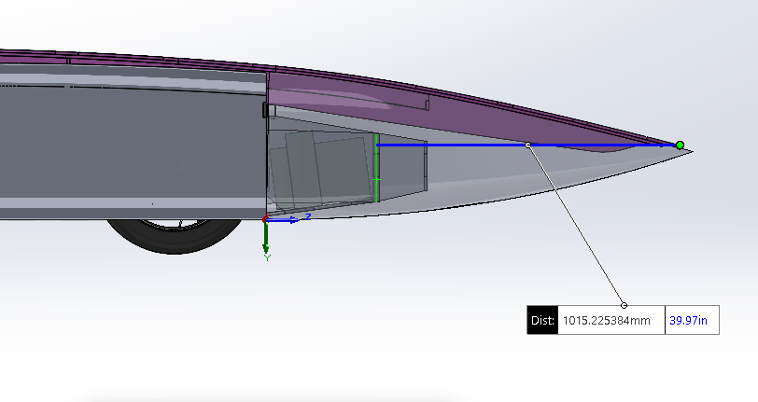
Figure 5.5: Front Crush Zone Distance Measurement

3.3.4 Mean Force on Safety Cell - Factor of Safety
To calculate the force on the safety cell during a 50mph head-on collision, we will use the impact force equation (below).
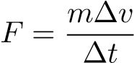
m = 450 lbs = 204.117kg
∆v = 50mph = 22.352 m/s
∆t = 0.09216s

The expected force on the safety cell is 49,520 newtons, which is a safety factor of 3.3 compared to the maximum force the safety cell can handle (165,365 newtons).

Chapter 4

Collisions from Other Angles
While we could analyze every angle to the same extent as a head-on collision, that would make this document incredibly long and repetitive. Instead, we will share how we expect the car to react to different collisions from an analytical perspective.

4.1 Driver’s Right Impact
Many areas of the car could contribute to the absorption of energy from the driver’s right side. First, our strong array will contribute to slowing the moving vehicle down before reaching the body. Next there is a solid wall constructed of Gillfloor that will absorb any additional large amount of energy. Finally, there are two bulkheads located in the safety zone that will absorb any final energy (, Fig. 6.1). EMBER’s front and rear suspension and wheels can also absorb energy in extreme cases. The safety cell is stiffened by both the roll bar assembly and the seat, which involves carbon fiber paneling spanning across the safety cell. This creates a stiff box structure that we expect to stay intact while the crush zone crushes.

4.2 Driver’s Left Impact
The left crush zones are similar to the right crush zones, but there are some differences. For example, the hinges located on the left side, which will add a small amount of rigidity to the crush zone. Other than the hinges, the safety cell behaves the same on the left as the right, staying a stiff, in-tact structure, while the crush zone crushes.

4.3 Rear Impact
A high inertia rear impact is unlikely, but the structure designed to hold the rear suspension also doubles as a great crush structure. There is a lot of surface area parallel to the force that can be crushed to protect the driver.
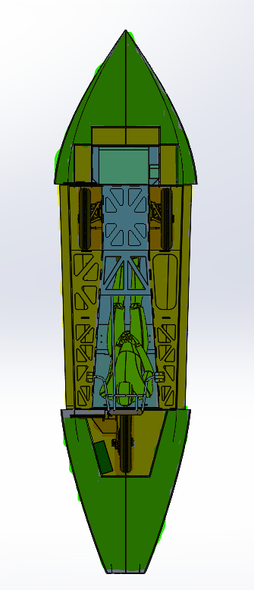
Figure 6.1: Crush Zone Visualization. Blue is the safety cell, Green is crush zone protected by the array, yellow is crush zone primarily protected by car elements, and orange is primarily protected by suspension elements.

Chapter 5

Conclusion
The results from the energy absorption test and edge compression test indicate that the crush zones are more than enough to bring the car to a complete stop, and we expect the safety cell to stay intact during a head-on collision at our expected race pace of 50mph. We expect crush zones on the sides and rear of EMBER to crush in a similar way, absorbing energy in other scenarios.
The results from the one-sided tensile strength test conducted at Boeing indicate that the roll bar’s bond to the composite structure is extremely strong, with a factor of safety of over four for a vertical impact of 10Gs.
While it is essentially impossible to compare metal to composites directly, the test results indicate that our specific application of composite materials is adequate to protect the driver in any reasonably likely crash scenario for a closed track event.

Chapter 6

Acknowledgements
First of all, we would like to give great thanks to Dr. Alain Semet, who has been a great mentor and supervisor throughout the entire project, and a mentor for the team for a long time before.
We would also like to extend a huge thanks to Kurt Gustafson, who took time out of his busy schedule to advise our engineering decisions, destructive testing, and ultimately, with the creation of this paper.
We would like to Acknowledge Raisbecks UWHS English Teacher, Marcie Wombold, also took time out of her very busy schedule to give invaluable feedback and a new perspective on the wording and organization of the first version of the document.
Finally we would like to thank the entire team for editing and commenting on the paper to ensure that it is logically sound and representative of our design.
Of course, this also would not be possible without all those involved in the organization of the Solar Car Challenge. The team is extremely thankful to have been part of such an impact program. This document is a compilation of years of work, experience gained, and lessons learned.
Chapter 7

Appendix
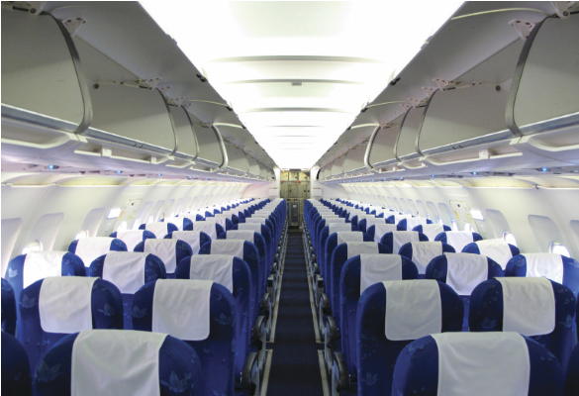
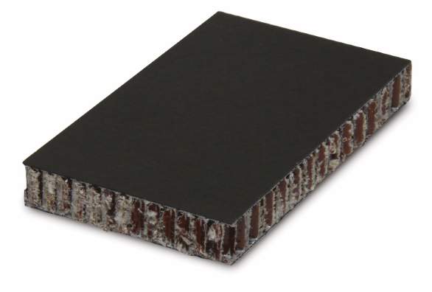
Gillfloor® 4709 PRODUCT DATA SHEET

^{DESCRIPTION}Gillfloor® 4709 is a light-weight, high-strength flooring panel made from unidirectional
carbon fiber reinforced epoxy facings bonded to meta-aramid honeycomb core. Outer panel surfaces feature fiberglass overlay to help protect against galvanic corrosion. Light-weight, high-strength panels designed for use as flooring in passenger APPLICATIONS compartments of commercial aircraft where weight, durability and strength are a major consideration.
FEATURES
- Good impact strength
- Carbon facings achieve 10-12% weight savings as compared tounidirectional glass reinforced material
- Excellent machinability and bonding surfaces
- Resistant to galvanic corrosion
- Good strength-to-weight and stiffness-to-weight ratios
- Light weight and low panel deflection under load
AVAILABILITY
Length, inch (mm) | Typical 144 (3,658)
Width, inch (mm) | Typical 48 (1,219)
Thickness, inch (mm) 0.40 (10.16)
CONSTRUCTION Adhesive: _{Epoxy film}

Core: Gillcore® HD meta-aramid honeycomb
Reinforcement: Unidirectional carbon fiber with fiberglass overlay
Resin System: Epoxy
Facing: Top: 0.010 inch (0.25 mm); Bottom: 0.010 inch (0.25 mm)
SPECIFICATIONS

- Qualified to Boeing BMS 4-20, Type II and Type III
- FAR 25.853 - fire resistant
^{HEALTH PRECAUTIONS}

This product is safe to use and apply when recommended precautions are followed. Before using this product, read and understand the Safety Data Sheet (SDS), which provides information on health, physical and environmental hazards, handling precautions and first aid recommendations. A SDS is available at https://www.thegillcorp.com/msds.php.
For industrial use only. Keep away from children. Additional information can be found at: www.thegillcorp.com. For sales and ordering information call 1-626-443-6094.
F203 – 9/21 Updated: 12/01/19
626-443-4022 | www.thegillcorp.com
4056 Easy Street, El Monte, CA 91731-1087, USA info@thegillcorp.com
Figure 9.1: Gillfloor 4709 Data Sheet
5/4/2023

Sample ID: Hailin pound-force 3 Point Bend 18 Inch Span.mss Test Date: 5/4/2023
Method: Hailin Flexure 3 Point Bend.msm Operator: Kelly

Sample Results:
Specimen Results:
Specimen # | Specimen ID | Width in | Thickness  in | Test Speed in/min | Peak Load  pound-force
1 | 1 | 3.044 | 0.407 | 0.500 | 203.5
2 | 2 | 3.023 | 0.404 | 0.500 | 178.9
3 | 3 | 3.014 | 0.406 | 0.500 | 195.5
4 | 4 | 2.990 | 0.406 | 0.500 | 180.5
5 | 5 | 3.018 | 0.405 | 0.500 | 199.7
Mean |  | 3.018 | 0.406 | 0.500 | 191.6
Std. Dev. |  | 0.019 | 0.001 | 0.000 | 11.3
% COV |  | 0.64 | 0.28 | 0.00 | 5.88

Specimen Comments:
1 | Compressive skin failure at load nose
2 | Compressive skin failure at load nose
3 | Compressive skin failure at load nose
4 | Compressive skin failure at load nose
5 | Compressive skin failure at load nose
Specimen # Comments

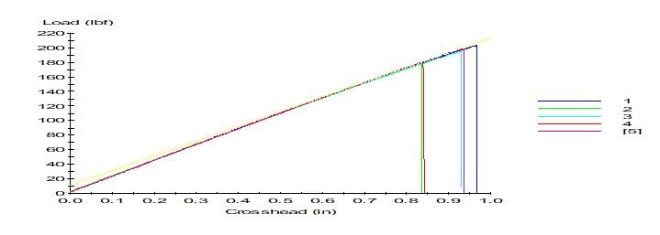

Boeing Proprietary
Figure 9.2: Three point bend test data as sent from Boeing
5/5/2023

Sample ID: Hailin Insert Tension.mss Test Date: 5/5/2023
Method: Hailin Tension Test.msm Operator: Roseen

Specimen Results:
Specime  n # | Specimen  ID | Test Speed in/min | Peak Load  pound-force
1 | TNS-1 | 0.05000 | 9007.5
2 | TNS-2 | 0.05000 | 7561.5
3 | TNS-3 | 0.05000 | 7909.6
4 | TNS-4 | 0.05000 | 7996.8
5 | TNS-1B | 0.05000 | 591.3
Mean |  | 0.05000 | 6613.3
Std. Dev. |  | 0.00000 | 3409.2

Specimen Comments:
Specimen # | Comments
1
2
3
4
5

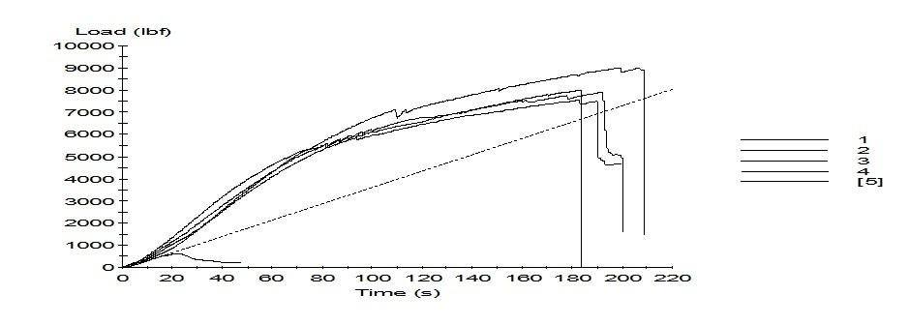

Figure 9.3: Two sided tension test data as sent from Boeing
6/25/2023

Sample ID: Tensile Ultimate Laod.mss Test Date: 6/25/2023
Method: Tensile Ultimate Load.msm Operator: Kelly

Sample Results:
Specimen Results:
Specimen # | Specimen ID | Test Speed in/min | Peak Load  pound-force | Time to  Failure min
1 | 1 | 0.050 | 2878.622 | 2.8
2 | 2 | 0.050 | 4129.079 | 3.9
3 | 3 | 0.050 | 3233.783 | 2.2
4 | 4 | 0.050 | 3761.897 | 2.9
5 | 5 | 0.050 | 3247.839 | 2.3

Specimen Comments:
1
2
3
4
5
Specimen # Comments

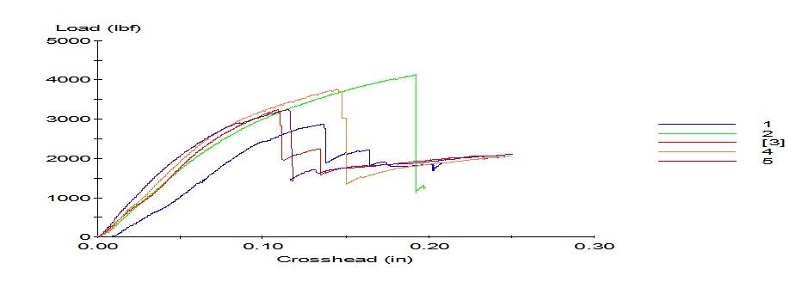

Figure 9.4: One sided tension test data as sent from Boeing

